DHA Suffa University

Department of Computer Science
CS 1001L – Programming Fundamentals Lab

Fall 2022

Lab 12 – Recursion

Objective:

- What is Recursion
- To learn Recursion in C
- Implementation of Recursion in C.

Recursion in C

Recursion is the process of repeating items in a self-similar way. In programming languages, if a program allows you to call a function inside the same function, then it is called a recursive call of the function.

What is Recursion ?
Recursion can be defined as the technique of replicating or doing again an activity in a self-similar way calling itself again and again, and the process continues till specific condition reaches. calling the function from itself can be termed as recursion, and the function in which makes this possible is called recursive function.

Example 01(example01.c): Number Factorial
Code Implementation in C:
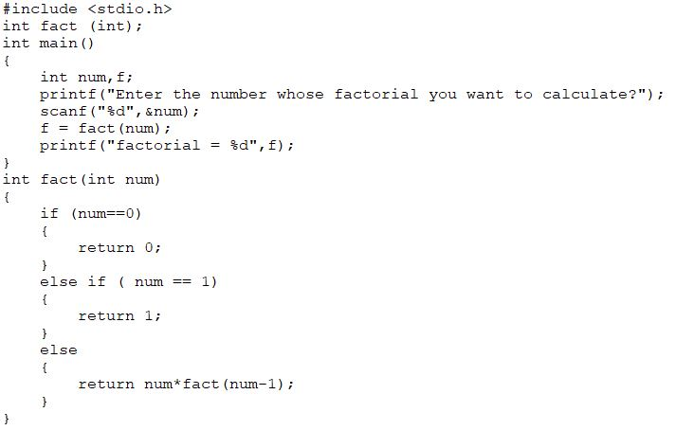

Example 02(example02.c): Sum of Natural Numbers Using Recursion
Code Implementation in C:
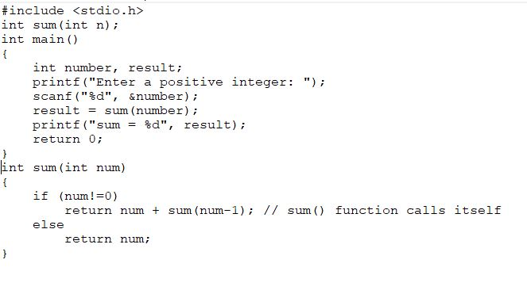

Example 03(example03.c): Power of any number using recursion
Code Implementation in C:

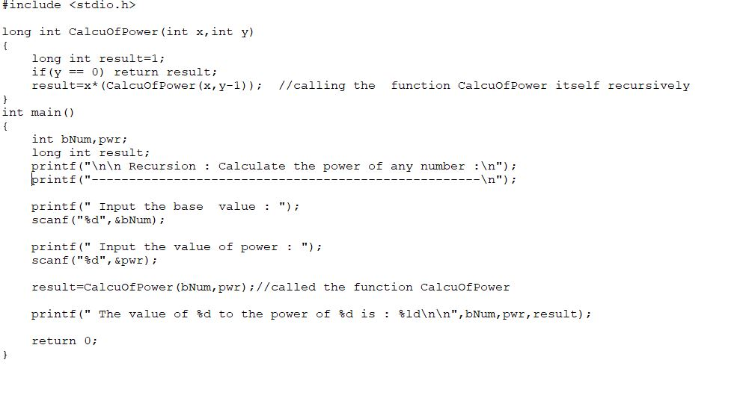

Example 04(example04.c): Fibonacci Series.
Code Implementation in C:
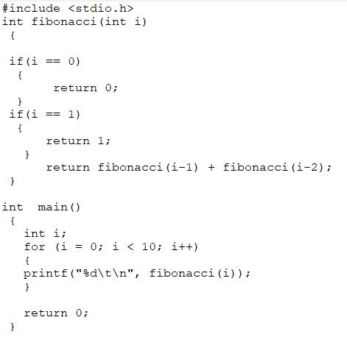
Example 05(example05.c):
Code Implementation in C:
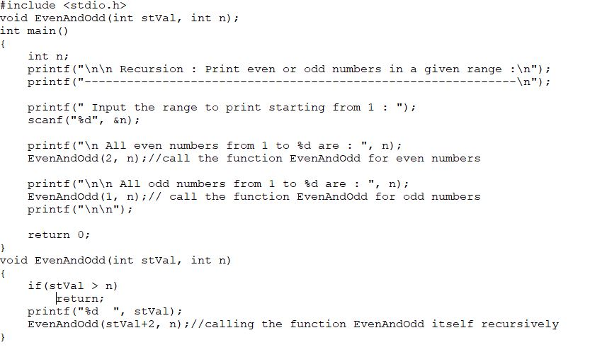

Lab Assignment 10

Q1(question01.c): Write a program in C to find GCD of two numbers using recursion.
Sample Output:
Input 1st number: 10
Input 2nd number: 50
Expected Output : The GCD of 10 and 50 is: 10

Q2(question02.c):Write a program in C to find the LCM of two numbers using recursion.
Sample Output:
Input 1st number for LCM : 4
Input 2nd number for LCM : 6
Expected Output :The LCM of 4 and 6 : 12

Submission Guidelines

- Place all files in a folder named your roll number e.g. SE211001.
- Compress all files into one (.zip) file named same as your roll number.
- Upload it on LMS.
- Submission Deadline:

- Note: -100 policy for plagiarism.

